**Autonomous Terrain Mapping and Asset Localization using Wheel-Based Rovers**

*Students*: [Mallika Lakshminarayan](mailto:lakshminam@vcu.edu), [Tahshon Holmes](mailto:holmesta4@vcu.edu), [Imanol Murillo](mailto:murilloir@vcu.edu), [Luke Unterman](mailto:untermanlm@vcu.edu)

*Advisor*: Dr. Tamer M. Nadeem

It was found that nurses can spend between 20-60 minutes looking for lost equipment.[1] A hospital cannot afford to lose any of its limited resources at critical moments, so there is a need to track them. However, methods like record-keeping and manual checks can be time consuming and prone to error, and mistakes in patient care can have dire consequences. **Our project is aimed at developing an accurate and novel wheel-based asset management system that can track movement of an asset in real-time without relying on external GPS or user-dependent input as a means to decrease time spent searching for vital assets and increase efficiency of patient care.**

The design behind our product is a real-time localization system application that is product-agnostic with fine detail accuracy that can be implemented in a wide variety of use cases. Our product interprets rotational velocity readings from two (or more) optical rotary encoders placed on individual wheels of the object and extracts information such as distance traveled and relative location using trigonometric transformations and heading calculations. From this information, we can overlay a user interface to track and manage assets in indoor and outdoor environments. Furthermore, we aim to utilize our wheel-based asset management system in conjunction with a SLAM-like layer to map and traverse unknown environments which are inaccessible and/or hazardous to humans.

The innovative nature of our project can be broken into two parts. The first part is to further the development of real-time tracking and management systems for wheel-based objects such as bikes, wheelchairs, and cars based on low-cost optical rotary sensors. Unlike any other localization system, the developed sensing system is based on deploying rotational sensors on the wheels themselves making it more accurate in detecting the distance, speed, and directions of the wheels. The system also works with any type of wheel/object as well as indoor and outdoor localizations. The second part is to further development in the field of robotics/autonomous mapping such that our system can autonomously traverse unknown environments while also simultaneously creating a detailed map of its surrounding area.

Wheel based mapping of this kind can be used in a variety of applications outside of tracking assets. In situations where evacuation is deemed necessary, understanding the layout of the environment enables emergency responders to save as many people as possible. Traditional evacuations usually lack the precision to handle complex terrains, but autonomous rovo-mapping would allow for accurately planned and executed evacuation routes. Another application of rovo-mapping could be optimizing building layouts for accessibility and functionality - using rovo-mapping addresses critical needs for individuals with disabilities, ensuring spaces are not only aesthetically pleasing but also inclusive and efficient, with potential applications for both new constructions and renovations. The modularization of our design allows it to fit for a diverse array of applications.

| **Expenses** | **# of Units** | **Unit Rate ($)** | **Costs ($)** |
| --- | --- | --- | --- |
| **Built Sensor:** | | | |
| Go Direct Rotary Optical Encoder | 3 | 189 | 567 |
| Pasco Wireless Rotary Motion Sensor | 1 | 199 | 199 |
| **Raspberry Pi + Accessories:** | | | |
| Raspberry Pi | 2 | 140 | 280 |
| Keyboard | 1 | 20 | 20 |
| Mouse | 1 | 10 | 10 |
| Misc Costs | 1 | 100 | 100 |
| **Assembled Sensor Components:** | | | |
| Female to Female Jumper Dupont Wire Cables | 1 | 5 | 5 |
| Male to Female Jumper Dupont Wire Cables | 1 | 5 | 5 |
| HC-05 Bluetooth Module | 2 | 14 | 28 |
| USB to TTL Adapter | 1 | 8 | 8 |
| **Building Materials:** | | | |
| Zip Ties | 1 | 5 | 5 |
| C-Clamps | 2 | 16 | 32 |
| Foam | 2 | 12 | 24 |
| Misc Costs | 1 | 100 | 100 |
| **Materials for SLAM implementation:** | | | |
| Rover | 1 | 150 | 150 |
| Camera | 2 | 50 | 100 |
| LIDAR sensors | 2 | 50 | 100 |
| ***Total*** | | | **1733** |

**Budget Justification and Utilization:**

Our protocol requires accurate positioning without the use of GPS. To accomplish this we must test various sensors and determine which minimizes drift the most. Our hypothesis is that a rotary optical encoder will be the most accurate, so we have selected multiple built rotary sensors and designed a schematic for our own bluetooth rotary optical encoder to compare performance. For the next phase of our project, we will have to develop the autonomous mapping component. At this point, we estimate that we will need other sensors to provide visual and distance input, but there are various SLAM algorithms that require differing inputs, so we will not know exactly how many of each resource we may need.

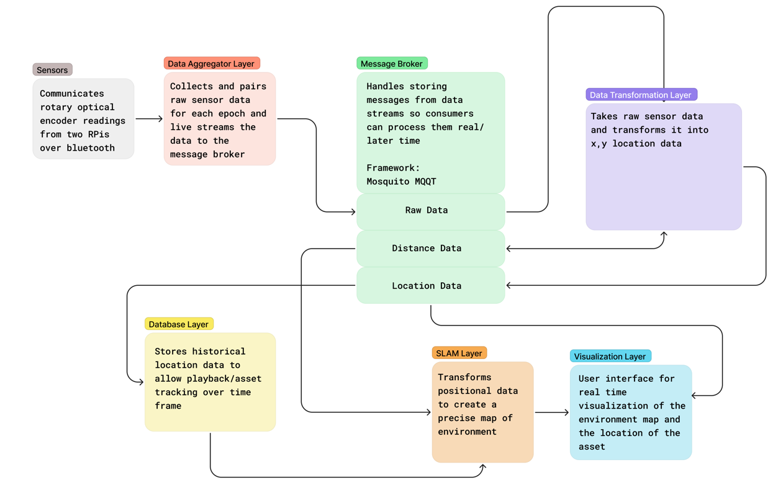

1. [Applying RTLS Technology to Improve Nurse Efficiency and Patient Care](https://www.himss.org/resources/applying-rtls-technology-improve-nurse-efficiency-and-patient-care#:~:text=In%20a%20study%20conducted%20by,shift%20searching%20for%20lost%20equipment.&text=One%20health%20system%20in%20Buffalo,looking%20for%20and%20cleaning%20equipment.)